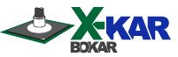

INSTRUCTION MANUAL

X-106AC MiniOven

Full Convection, Bench-top oven with nitrogen input and fast cooling

Especially designed for Re-Balling and LEAD FREE Soldering of smaller boards

(size 6”x 4.7” or less)

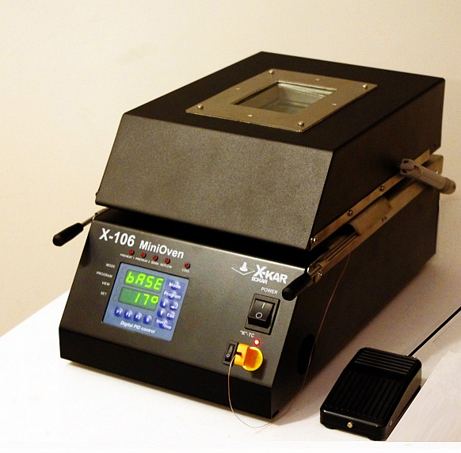

P/N X-DOC998

Date: Jan 2015

Rev. 1

650 Scranton Pocono Hwy  Covington Twp., Pa 18444, USA  Tel: (570) 842-2812 Fax: (570) 842-4290  E-Mail: bokar@bokar.com  www.bokar.com www.SMT-ESD.com www.ESDmeters.com www.SMTreballing.net  www.Assembly-SMT.com www.X-Reflow306.com | 

TABLE OF CONTENTS
PAGE
I. INTRODUCTION 2
II. SAFETY 2
III. PACKAGING 3
IV. UNPACKING 4
V. GENERAL INFORMATION 4
VI. SET-UP AND INSTALLATION 5
VII. SYSTEM DESCRIPTION AND APPLICATION 6
VIII. FIRMWARE UPGRADE 11
IX. TECHNICAL SPECIFICATIONS 12
X. HOW TO PRE-PROGRAM A PROFILE 14
XI. SPARE PARTS LIST 15

INTRODUCTION
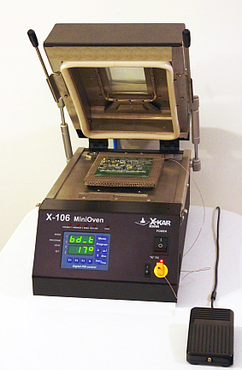

FIG. 1 VIEW OF THE SYSTEM

Thank you for purchasing „X-106AC MiniOven”.

BOKAR International retains the right to make changes to specifications contained herein at any time, without notice. Please contact your local authorized Distributor or Bokar International to obtain the latest specifications.
This manual will provide you with the information necessary to properly set up, operate and maintain the X-106 MiniOven unit. Please read this manual carefully before using the system.

SAFETY
The purpose of this "SAFETY" section is to inform the users of the heading guidelines used in this manual to indicate special Notes, Cautions, Warnings or Dangers. Also included are precautions, which must be observed when operating or servicing this product.
These "NOTES", "CAUTIONS", "WARNINGS" and "DANGERS" are inserted in this manual whenever deemed necessary. They appear in a blocked off form with outline and a shaded background to highlight the information as shown below.

NOTE
xxxxxxxxxxxxxxxxxxxxxxxxxxxxxxxxxxxxxxxxxxxxxxxxxxxxxxxxx

NOTE
Used to indicate a statement of company recommendation or policy. The message may relate directly or indirectly to the safety of personnel or protection of property. NOTE is not associated directly with a hazard or hazardous situation and is not used in place of "CAUTION", "WARNING" or "DANGER".

CAUTION
Used to indicate a hazardous situation, which may result in minor or moderate injury. May also be used to alert personnel to conditions, procedures and practices which, if not observed, could result in damage to or destruction of the product or other equipment.

WARNING
Used to define additional information, that if not closely followed may result in serious damage to equipment and represent a potential for serious personnel injury.

DANGER
Defines additional information, that if not closely followed may result in severe personnel injury or death. Danger is not used for property damage unless personal injury risk is present.

PRECAUTIONS
The following are general safety precautions, which personnel must understand and follow when using or servicing this product. These precautions may or may not be included elsewhere in this manual.
CAUTIONS
- Utilize all standard electrical safety precautions when using this or any other electrical equipment.
- Always use this system in a well-ventilated area.
- Exercise proper precautions when using chemicals (e.g., solder paste). Refer to the Material Safety Data Sheet (MSDS) supplied with each chemical and adhere to all safety precautions recommended by the manufacturer.
- The fumes emitted during soldering are irritants and therefore should be removed. A pumped vent is located at the rear of the unit and should be ducted accordingly.
- The area close to the hood becomes hot; therefore, care should be taken when working around this area.
- This oven must be properly grounded.
- Please read this operation manual carefully prior to use.
- The area around the viewing window becomes hot; therefore, care should be taken when working around this area.
- After ending the cooling cycle, the inside of the oven is still hot; therefore, care should be taken when removing and mounting the PCB.
- Be sure to wear appropriate gloves to prevent burns when taking the PCBs out of the oven and placing new ones. The PCB is still hot. The temperatures inside the oven may be as high as 350 deg. Celsius.

NOTES
To insure continued peak performance, use genuine X-KAR replacement parts.

WARNING
This appliance is not intended for use by persons (including children) with reduced physical, sensory or mental capabilities, or lack of experience and knowledge, unless they have been given supervision or instruction concerning use of the appliance by a person responsible for their safety.

Children should be supervised to ensure that they do not play with the appliance.

PACKAGING
The packaging of the X-106AC Mini Oven has been carefully designed to ensure maximum protection during shipping. However, no packaging can guarantee 100% protection, and damage may occur through rough handing by the carrier. Please ensure that any claims for shipping damage are reported promptly to the carrier and to the Distributor from whom the product was purchased.

The content of the box is as follows:
  - X-106 MiniOven Unit
  - 3-foot long “K” Thermocouple
  - XFS-3 Foot Switch
  - Power Cord
  - User’s Manual
  - Guarantee card

UNPACKING

Prior to use of the system, please check if the system is complete. Should you notice that any items are missing, please notify us, giving the details of model number, voltage, date of purchase, where purchased and what is missing. Missing items must be reported within 7 days from the date of purchase.

WARNING
When unpacking, please be careful and read the manual prior to turning the system “ON”. Please check that the voltage of the System corresponds with the voltage of your available supply. Connection to incorrect voltage supply may cause damage to the System!

GENERAL INFORMATION
FRONT PANEL  - POWER Switch  Turns the system ON and OFF. Green light indicates that the system is ON.  - Thermocouple indicator  Illuminates red when measurement is activated and the thermocouple is connected to the units or blinks when the measurement is activated and the thermocouple is not connected or is open.  - Thermocouple connector  Socket to connect external “K” thermocouple.  - Thermocouple switch  When “ON” the temperature measured by an external thermocouple is displayed on the bottom display panel.  - Digital Control Panel  Please see below. | 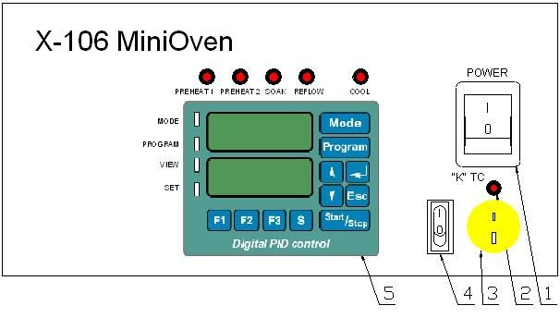  FIG. 2 VIEW OF THE CONTROL PANEL
BACK PANEL  - AC power receptacle  Provides AC power to the system through an appropriate to the country standard power cord.  - Fuse holder  Contains a 32 mm type fuse for overload protection (value depends on AC supply 20A for 115V and 10A for 230V supply)  - X-DataStore  PC Interface used for Firmware Upgrades.  - Foot switch connector Foot switch connected to the unit allows for an advance to the next zone during execution of the profile.  - NITROGEN connector  - Cooling Air input  - Exhaust of Cooling Air | 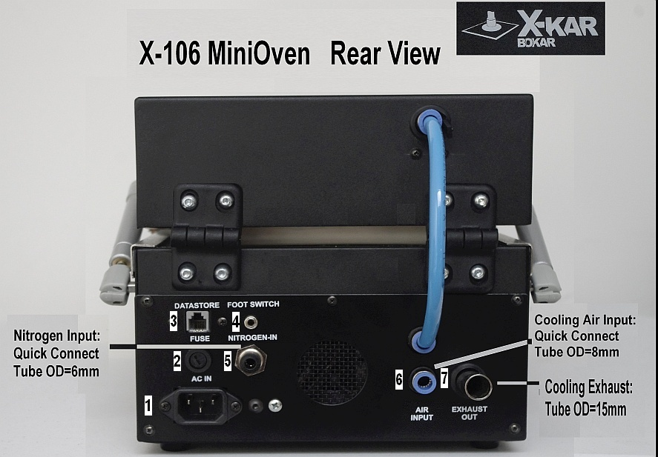  FIG. 3 VIEW OF THE BACK PANEL

DIGITAL CONTROL PANEL  - Set indicator - Illuminates Green when the system is in Set mode of operation.  - View indicator - Illuminates Green when the system is in View mode of operation.  - Program indicator - Illuminates Green when the system is in Program change mode of operation.  - Mode indicator - Illuminates Green when the system is in Mode change of operation.  - Preheat 1 indicator - Illuminates Red when the system is in the first preheat zone.  - Preheat 2 indicator - Illuminates Red when the system is in the second preheat zone.  - Soak indicator - Illuminates Red when the system is in the soak zone.  - Reflow indicator - Illuminates Red when the system is in the reflow zone.  - Cool indicator - Illuminates Red when the system is in the cooling mode. | 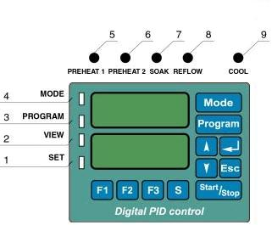  FIG. 4 VIEW OF THE DIGITAL CONTROL PANEL

SET-UP AND INSTALLATION

ELECTRICAL REQUIREMENTS
The X-106AC MiniOven unit consumes 2250 Watts of power. If your power outlet cannot provide suitable power, arrange for a qualified, licensed electrician to install one for you.

SET-UP
- Remove the “X-106 MiniOven” from its shipping box. Store the shipping box in a convenient location. Reusing this box will prevent damage if you ship or store the system
- The system should be located on a stable work surface.
- Confirm that the power switch on the front panel is in the “OFF” position.
- Open the Top Clam Shell and check if there are no accessories or documentation inside the oven.
- If you wish to use nitrogen, attach the nitrogen source (0.5~1 kg/cm²) to the nitrogen input port on the rear panel of the oven. The connection is via standard quick connect accepting a tube of OD= 6mm.
- Connect XFS-3 foot switch to the connector on the back panel of the “X-106 MiniOven” base unit.
- Connect compressed air for cooling. The connection is via standard quick connect accepting a tube
of OD= 8mm.
- Connect AC power to a suitable AC power outlet.

SYSTEM DESCRIPTION AND APPLICATION

Description of Front Panel Key Pad Functions and Programming

 | MODE key allows selecting the MODE or changing the MODE.
 | PROGRAM key allows selecting the PROGRAM or changing the program to the next one.
and | UP and DOWN keys change viewed parameter during parameters preview, increase or decrease the value of parameter during its modification.
 | ESCAPE key allows for cancellation of the action in progress (e.g. modification of a parameter). Also it allows leaving the VIEWING or MODIFICATION mode. Also, instantly ends the profile cycle.
 | ENTER key allows for confirmation of new parameter value, selected MODE or PROGRAM number. Also, when the system is pre-programmed and ready for operation (Top display shows Mode and Program number and bottom display shows “Go”) pressing ENTER key will access directly Nozzle Offset entry mode.
 | START/STOP key allows starting and pausing the process. The process can also be started or paused by pressing “Heat” Switch on the Hand piece (if this switch was pre-programmed this way). To end the process after pausing it, the “ESC” key on the keyboard needs to be pressed.
 | F1 key allows viewing the values of parameters of the MODE and PROGRAM currently selected at the time of pressing F1 key.
 | F2 key allows entering modification mode of currently viewed parameter.
+ | Keys F1 and MODE, when pressed together for more than 0,5 sec. allow to enter the user menu which allows to set system parameters.
F3 Key, when pressed, turns on or off the BLOWER at any time.
During the execution of thermal profile, pressing the F3 Key advances the profile immediately to a cooling zone.
 | S Key is not allowed.

System Operation

When the system is turned "ON" the display shows for about 1 second. After 1 second the display will show MODE and PROGRAM, which was used last, before the system was "turned off".
The Modes to choose from are as follows:

Base Mode In this mode the oven maintains constant pre-programmed temperature.

Base Mode is the mode in which the operator controls process time. The process time may be controlled in two different ways or in any combination of the three ways. The process may be started and stopped from the main keypad or the foot switch.
KEYPAD – Pressing the start/stop key the first time will start the process and pressing it again will pause the process. Press escape to end the process completely.
FOOT SWITCH -- Pressing the foot switch the first time will start the process and pressing the foot switch a second time will stop the process completely.

Profile Mode in which the duration of each zone and temperature in each zone are pre-programmed and controlled automatically by microprocessor. Precisely pre-programmed cycle (profile) can be repeated every time the operator presses the Foot Switch or Start/Stop key. There is one (1) pre-programmed sample profile and 89 user programmable profiles to be used by the operator as needed.
During an automatic cycle (the duration of a profile) an operator has four additional options:
- He/she can pause the process by pressing Start/Stop key on the control panel keyboard and can re-start it again from the point where he/she stopped it, by pressing the Start/Stop key again.
- He/she can advance to the next zone (skip time left to the end of the zone) by pressing the Foot Switch.
- He/she can press key to end the process (profile) at any time during the duration of a profile.
- He/she can press key to end the process (profile) and start cooling zone at any time during the duration of a profile.

Mode In this mode the heaters in the oven are controlled by the thermocouple attached to the heated object.

Note: If the controlling thermocouple is not connected to the TC socket on the front panel, the error message shows on the bottom display.

The three possible mode of operation appear on the unit key-pad as shown below:
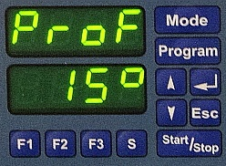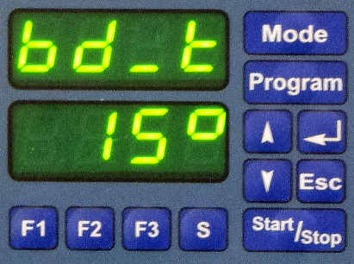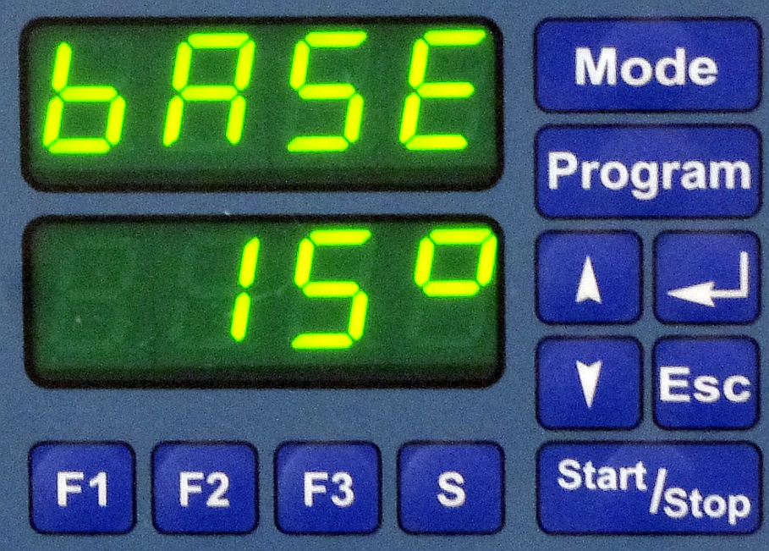
Oven control by setting air temperature as a temperature-time profile
Oven control by setting desired object temperature as a temperature-time profile
Oven control by setting one constantly maintained air temperature in the oven

MODE or PROGRAM cannot be changed when the profile cycle is in progress.
Pressing either MODE or PROGRAM key during the profile cycle in progress (or during parameter change) will display actual Mode and Program for 2 sec.
It is possible to change the parameters of the PROGRAM, which is actually run by pressing key to view pre-set value and key to access a parameter change. At this point, the parameter can be changed by using Up and Down arrows to set required value and the change to take effect has to be confirmed by pressing
One can change his/her mind and decide not to change the parameter value. At this point pressing key will erase the initiated change and the program will return to the original parameter value.

PROGRAMMING THE UNIT

CHANGING OR VIEWING SYSTEM SETTINGS
- Press and key simultaneously for about 2.5 seconds. The displays will show . After few seconds, the displays show first system setting.
- Settings can be viewed by pressing UP or DOWN keys.

Lock Feature
The lock feature is used to limit the accessibility of an operator to Machine settings. Changes may only be used when a 4-digit code is entered.
-- When set to OFF no code is needed to make changes.
-- When set to On a code is required to make changes.
Factory setting: . Please see below for more detailed information on this function.
Code Change
See below for more information.
Temperature Display Setup
-- Displays the current temperature in Celsius (°C).
-- Displays the temperature in Fahrenheit (°F).
Factory setting:
System Counting
-- When set to “dn” the system will show the remaining time.
-- When set to “UP” the system will display the elapsed time.
Factory setting:
Temperature Rise / Time
Allows the operator to control how the temperature and time interact in each zone. The machine code must be entered to make changes to this setting.
-- Means that the setting in each zone is: top temperature, bottom temperature and the zone time. This is TBT or Top-Bottom-Time mode.
-- Means that the operator can set in each zone: 1. top temperature, 2. bottom temperature, 3. time in which temperature should rise to the set temperature, and 4. time during which the system should hold the set temperature. This is TBrH or Top-Bottom-Rise-Hold mode.
Sound ON/OFF
-- When set to ON the beep will be heard when pressing keyboard keys.
-- When set to OFF the unit will not make any sound.
Factory setting:
Thermocouple 3 Calibration Low
Please see below for calibration instructions.
Thermocouple 3 Calibration High
Please see below for calibration instructions.
Exits system settings.

Protection against unauthorized change of pre-programmed parameters

When system is unlocked system feature is set to . All parameters and system features can be altered without restrictions. When system feature is set to , the system will ask for a code number when someone will try to change pre-programmed values.
The Display will show: (First digit blinking). To unlock the system, previously selected code number must be entered. If incorrect value of the code number is entered, the display will show and sound will be heard for about one second. The system will re-set to the state it was in before an attempt to change the parameter. Properly entered code will unlock the system and allow for parameters change until the system is locked again or until the system is turned-off by ON/OFF switch (or by unplugging the unit from the wall outlet). It is sufficient to enter an appropriate code once during the time when the system is powered.

Changing the CODE:

has to be selected in system parameters menu (F1 + MODE). Then, key must be pressed. The display will than show (old code). Previously used code number must be entered and key pressed. The display will show (new code) and a new code number chosen by the user has to be entered. Display then will show and a new code has to be keyed in one more time. This new code will now be remembered by the system.

Special CODE numbers used by the system:
1234- factory set code on delivery of the system to a customer.
XXXX- „emergency code”; (call or e-mail Bokar International to obtain it. Proof of purchase will be required to release this code). This code will allow changing the code when entered in place of the old code.
YYYY- „master code”; this is manufacturers code which can be used in parallel or instead off the user code. Use of the “master code” does not interfere with currently used code number.

External thermocouple calibration:

NOTE
Please do not perform this calibration if it is not necessary. The unit has been calibrated in the factory and should not need re-calibration.

  - When you are in user settings menu and arrive at the window press ENTER.
  - The display will show:. Enter 4-digit code to access low calibration point.

NOTE
If the external TC is not connected to the unit the display will show Er. 17 and the beeper will sound to prompt you to connect the thermocouple.

  - When the code is entered correctly and the external TC is connected to the unit the display will show blinking temperature read by the external TC. Place the TC in known low temperature environment (e.g. ice bath), which you can measure with an independent and calibrated temperature meter. Read this temperature using the independent meter and enter correct value it into “X-106 MiniOven” unit. Press ENTER to confirm.
  - Press DOWN key.
  - The display will now show
  - Press ENTER and the display will show .
  - Enter the 4-digit code to access high calibration point.
  - You may use a container with boiling water as a reference for high calibration point.
  - Place the TC into the high temperature environment. Read this temperature using the independent meter and enter correct value it into “X-106 MiniOven” unit. Press ENTER to confirm.
  - The external TC is now calibrated. Press ESC to out of User settings menu.

Programming a profile

See below HOW TO PRE-PROGRAM A PROFILE

Mode change; (Led.1 is „ON”)

Pressing “Mode” key will recall actually used MODE. Pressing “Mode” again will advance mode sequentially in a close loop.
Profile Mode
TC Mode
Base Mode
Pressing “ENTER” key ends MODE change
Pressing “Esc” key also ends MODE change
Pressing “F1” key ends MODE change and enables viewing of pre-set parameters
Pressing “F2” key ends MODE change and enables change of the first parameter in a given MODE and a given PROGRAM
Pressing “START” key ends MODE change and starts the process

Program change; (Led.2 is „ON”)

Pressing “Program” key will recall actually used PROGRAM. Pressing “Program” key again will advance the PROGRAM sequentially in a close loop. One pre-programmed value is fixed (Program 1) and 89 other PROGRAMS are user programmable (programs 2, 3 ……90)
Pressing “ENTER” key ends PROGRAM change.
Pressing “Esc” key once returns to the PROGRAM number before initiated change. Pressing “Esc” key the second time also ends the PROGRAM change.
Pressing “F1” ends PROGRAM change and enables viewing of pre-set parameters
Pressing “F2” ends PROGRAM change and enables change of the first parameter in a given PROGRAM
Pressing “START” key ends PROGRAM change and starts the process

Viewing pre-programmed values and functions (Led.3 is “ON”)

Pressing “F1” key will allow viewing first parameter. Pressing “F1” key or key will advance viewed parameter sequentially in a close loop. Pressing will scroll the parameters in reverse.
Pressing “F2” stops viewing and enables a change of the viewed parameter
Pressing “Esc” key ends parameters viewing mode
Pressing “MODE” or “PROGRAM” enables viewing of current MODE or PROGRAM
Pressing “START” key ends parameters viewing mode and starts the process

Parameter value change (Led.4 is „ON”)

Pressing „arrow up” key will advance value sequentially in a close loop (value + 1)
Pressing „arrow down” key will cause the system to go back to a lower value sequentially in a close loop (value - 1)
Pressing “ENTER” key confirms new parameter value and will cause the system to go back to a parameters viewing mode
Pressing „Esc” key once returns to the parameter value before change. Pressing „Esc” key second time cause the system to go back to a parameters viewing mode
Pressing “MODE” or “PROGRAM” enables viewing of current MODE or PROGRAM
Pressing “START” key ends parameters value change and starts the process
Pressing “F2” allows to switch from temperature to time in the same zone

Viewing System Parameters (Led.3 is “ON”)

NOTE: To access System Set-up Menu two keys must be pressed at the same time: and for longer than 1/2 of a second.

Pressing „F1” key scrolls up through system parameters sequentially in a close loop
Pressing “F2” key allows entry into a viewed system parameter change
Pressing “Esc” key ends system parameters viewing mode
Pressing “MODE” and “PROGRAM” enables viewing of current MODE or PROGRAM
Pressing “START” key ends system parameters viewing and starts the process

System parameters modification after key is pressed (Led.4 is „ON”)

Pressing „arrow up” key will advance system parameters sequentially in a close loop
Pressing „arrow down” key will cause the system to go back to a previous system parameter sequentially in a close loop
Pressing “ENTER” key confirms new system parameter and will cause the system to go back to a system parameters viewing mode
Pressing “Esc” key ends system parameters viewing mode
Pressing “MODE” and “PROGRAM” enables viewing of current MODE or PROGRAM
Pressing “START” key cancels current parameter modification and starts the process

Offset Entry:

When the system Mode and Program was selected offset can be entered.
    - Press
    - The top display will show: and the bottom display will show: . The displays will change in one second.
    - After that the top display: and the bottom display: indicating pre-programmed offset in degrees Celsius or Fahrenheit (See above: Parameters, which may be pre-programmed).
    - Enter required value (measured by you or taken from the table included in this manual) using up and down arrows.
    - Press enter to finalize offset number entry. The system will now adjust temperature settings to compensate for the temperature drop between the nozzle entering point and the point of air (or nitrogen) exit from the nozzle to solder or de-solder the component.

NOTE
Each program stores offset independently so that you can set different value for each program (in other words you can use different program with different offset).

System information
LED Indicator
- Led 1 – MODE change
- Led.2 – PROGRAM change
- Led.3 – Parameters viewing mode in a given Program
- Led.4 – Values or System parameter change
Red LED Indicators Showing Zone during the Process or viewing pre-programmed parameters:
- PREHEAT - Preheat Zones. This LED indicates both preheat zones. It blinks slowly in PREHEAT1 and stays all the time “on” in PREHEAT2
- SOAK - Soak Zone (to equalize the temperature across the component)
- REFLOW - Reflow Zone in which the solder melts.
- COOL - Cooling Zone (To cool the component after reflow for more reliable connections)

USING EXTERNAL THERMOCOUPLE

    - To activate the temperature measurement by external thermocouple:
      - Connect thermocouple to the thermocouple connector.
      - Set the unit POWER Switch to “ON” position.
      - Set the Thermocouple Switch to “ON” position. Thermocouple indicator illuminates red when the thermocouple is connected. The red indicator blinks when the thermocouple is not connected or is broken.
      - Lower display shows temperature measured by the external thermocouple.

NOTE
When thermocouple is not connected, thermocouple indicator is blinking.

    - Turning the measurement by external thermocouple “OFF”:
      - Set the thermocouple switch to “OFF” position.

    - Thermocouple calibration:
      - Connect thermocouple to the thermocouple connector.
      - Set the unit POWER Switch to “ON” position.
      - Set the Thermocouple Switch to “ON” position. Thermocouple indicator illuminates red when the thermocouple is connected. The red indicator blinks when the thermocouple is not connected or is broken.
      - Press together keys F1 and MODE, for more than 0,5 sec. – you are in system parameters menu.
      - Select or to change low temperature or high temperature reference value for your thermocouple (see page 9).

FIRMWARE UPGRADE

Checking firmware revision and SN in the device.

- Connect the power cord
- Turn the Power Switch to the "ON" position.
- Press and hold “Esc” button.
- After a few second the displays should show:

Top display | Bottom display  (example values) | Description
Did | d070 | Device identifier
SoFt | 02.49 | Software revision
SN | 0102 | Serial number

How to upgrade the firmware in X-106 MiniOven in the future:

Reprogramming procedure
Receive the latest firmware version from Bokar International by e-mail.

- Copy file firmware XXX.zip and unpack this to one folder (All files must be in the same folder)
- Turn the Power Switch to the "OFF" position.
- Connect X-106 MiniOven (Data Store Connector) with PC (USB) via X485-USB converter.
NOTE: X485-USB Converter needs installed driver for proper operation.
If the converter is first connected to the PC, You should install the X485-USB driver.
- Press and hold “Enter” button on the device keyboard.
- Turn Power switch to ON position.
- Release “Enter” button. The oven display should show: “boot” “----“.
- Run program Flasher.exe on the PC (double click on the flasher icon)
- Flasher should find the serial port where the oven is connected.
- Flasher will ask “Do you want to start up update device?”,
- Select “Yes” to confirm and press “enter”.
- After upgrade is finished, You should get the message “Write successful. Would you like to run application?”
- Press “ENTER”
- Application will start.
- Flasher window will automatically close.

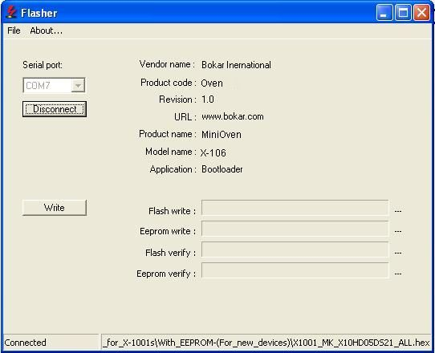

TECHNICAL SPECIFICATIONS

Input Voltages | 115V AC or 230V AC 50/60 Hz
Power Consumption | 1600W
Fuse | 20A for 115V; 8A for 230V
Heater Control | PID, Closed-Loop Thermocouple sensor feedback
Reflow area | 160x120x40 mm (6.3”x4.7”x1.57”)
Temperature range | 30 ºC – 350 ºC (86 ºF – 662 ºF)
Temperature Zones | Preheat1, Preheat2, Soak, Reflow, Cooling  – Total of 5 (five) zones
Heaters | 2 Heaters (Front and Rear) 0.88kW
Max. PCB size | 6” x 4.7” ~ (160 x 120) mm
Communication with PC | RS485 port ( XKAR X485-USB converter required to connect to PC USB port)
Weight | 12kg (26.5 lbs.)
System dimensions | 440mm x 267mm x 225mm (17.3” x 10.5” x 8.8”)
Packaged weight | 13.5kg (29.9 lbs.)

”X-106 MiniOven” pre-programmed Profiles
 |  | HEATING
 |  | Temperature |  | Time (s)
 |  | ⁰C | °F | Time (s)
BASE MODE Program | Max. Temperature | 400 | 752 | -----------
ProF Program | Preheat 1 | 120 | 248 | 30
ProF Program | Preheat 2 | 120 | 248 | 30
ProF Program | Soak | 150 | 302 | 30
ProF Program | Peak | 260 | 500 | 40
ProF Program | Cool | 100 | 212 | 120
bd_t Program | Preheat 1 | 100 | 212 | 30
bd_t Program | Preheat 2 | 100 | 212 | 30
bd_t Program | Soak | 160 | 320 | 60
bd_t Program | Peak | 240 | 464 | 60
bd_t Program | Cool | 100 | 212 | 120

HOW TO PRE-PROGRAM A PROFILE

NOTE
If the pre-heater “control setting” is set to off in the system setting menu, you will not be prompted to set the temperature values for the pre-heater and the system will not turn the pre-heater on and off.

- Connect the unit to appropriate power outlet.
- Set the power switch to the "ON" position. (The switch will illuminate when it is in the on position.)
- The TOP display will show "On" for about a second and then change and display the last mode and program number that was used before the unit was power off.
E.g. Top display (Profile Mode)
Bottom Display (Program #5)
- Press the key to increment the currently display program by one. After you have pressed the program key the initial time the program indicator will illuminate. You may continue to press the program key to move to the next program or you may use or arrow keys.
- Once you have the appropriate program number displayed, press the key to select the program.
- Press key to display the first parameter of the program (see the chart below for a list of parameters in each mode.)
- Use or arrow keys to move to and display the parameter which you wish to change.
- Press to select the parameter.
- Using or arrow keys to change the value of the parameter.
- Press key to save the value which you have changed. This will also return you to the parameter menu.
- Repeat steps 10 thru 13 to change other parameters.
- After you have finished making changes press key to end the parameter viewing mode.
- You are now ready to run the revised program.

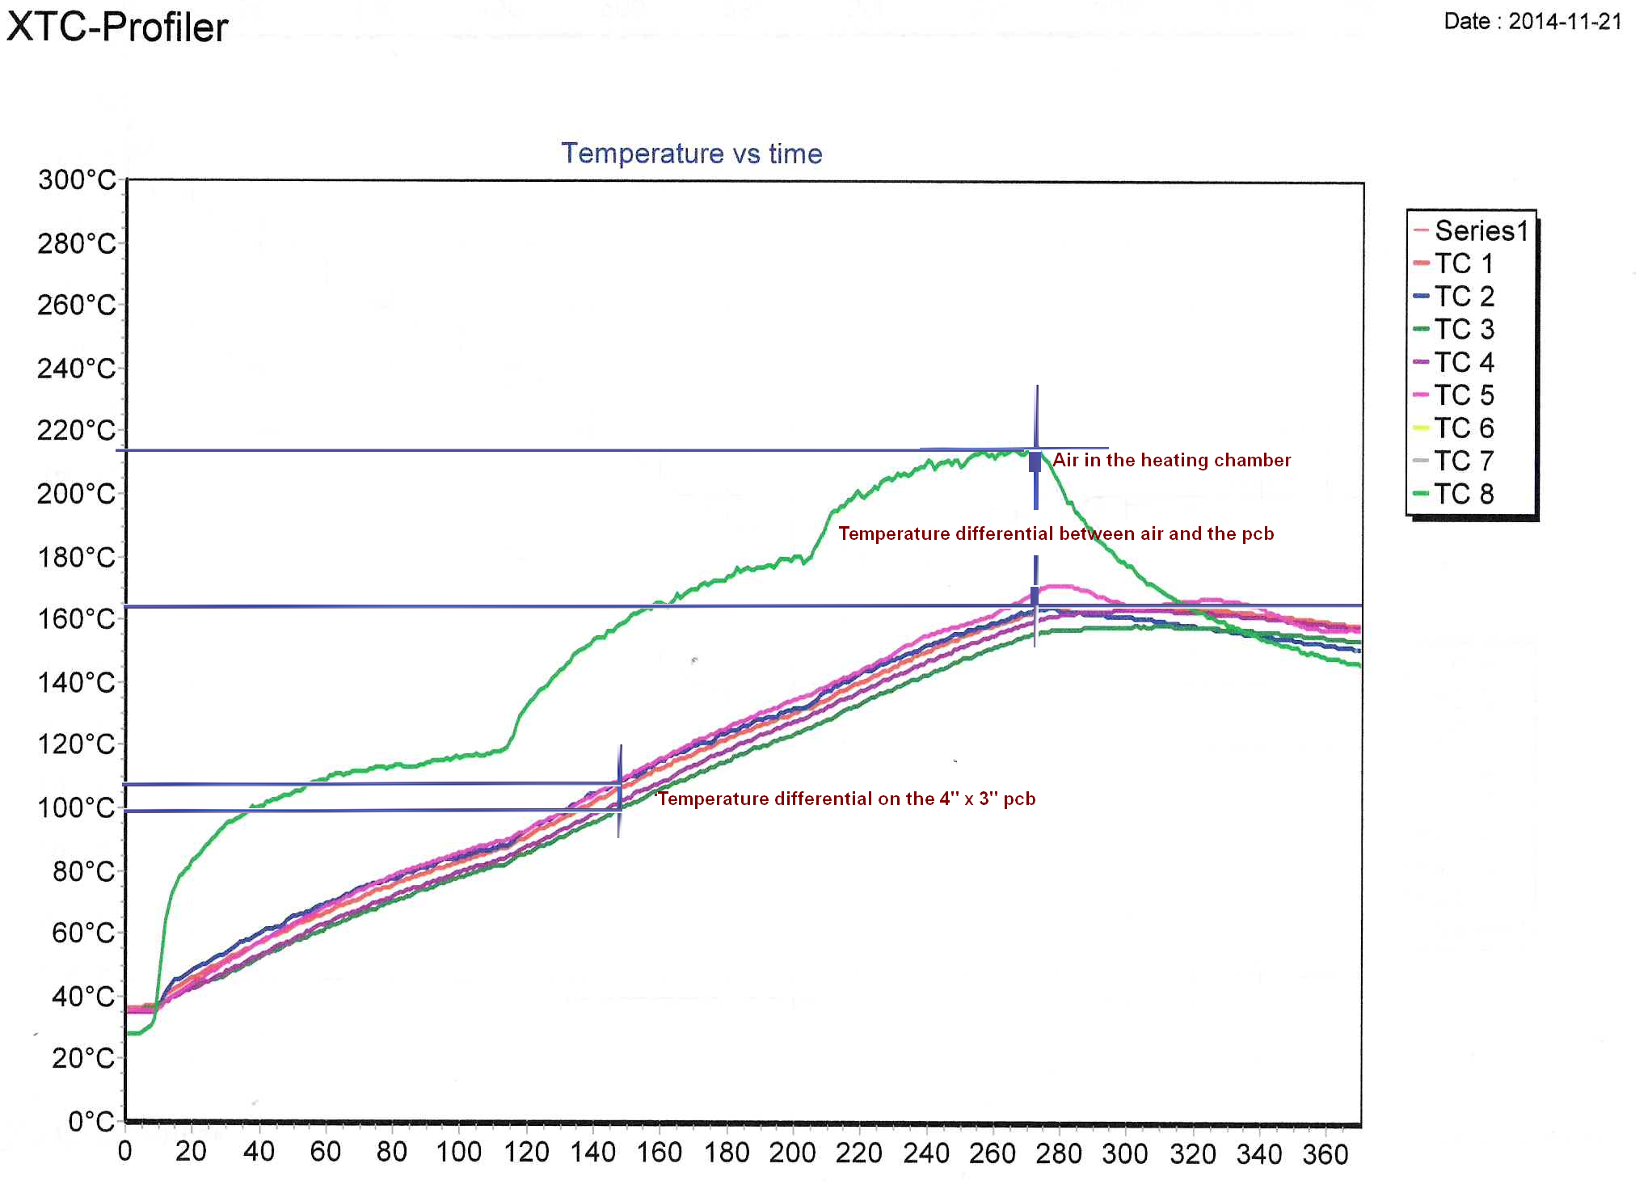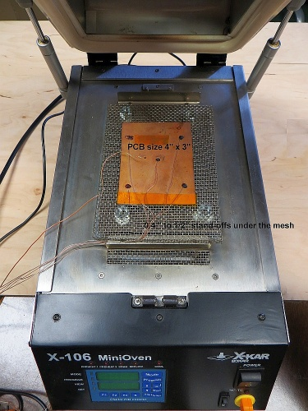

Example of temperature distribution on the pcb when oven heaters were controlled by the

thermocouple sensing air temperature in the heating chamber (measured by X-KAR SMT-Profiler)

REPLACEMENT PARTS LIST and Accessories

PN | Description
XK-TC 36/72" | "K" type thermocouple with mini connector in glass wrap and glass braid for temp. Up to 482 deg.C. Very thin-gauge 36. 72" long.
XK-TC 36/36" | "K" type thermocouple with mini connector in glass wrap and glass braid for temp. Up to 482 deg.C. Very thin-gauge 36. 36" long.
XK-TC 26/36" | "K" type thermocouple with mini connector in glass wrap and glass braid for temp. Up to 482 deg.C. Thin-gauge 26. 36" long.
30187S | Keyboard Pad
20100S | Power switch
30230S | Temperature control PCB
30869SF | Heater Assembly Front
30869SR | Heater Assembly Rear
XFS-3 | Foot Switch
X-106RS | Top clamshell gasket-seal
X-106RA | Top clamshell lift-absorber set (2 pcs)
X-106RT | X-106 Replacement thermocouple
X-106RG | X-106 Replacement Glass
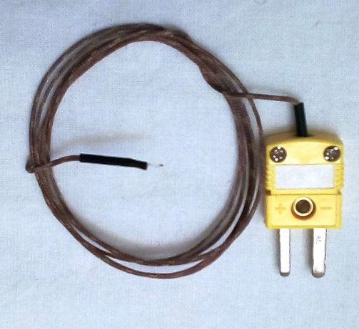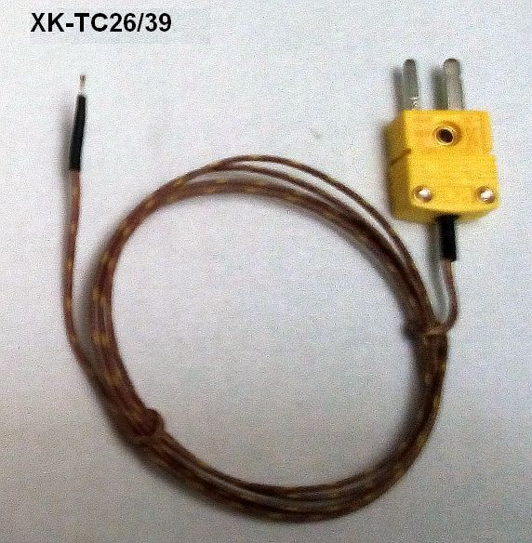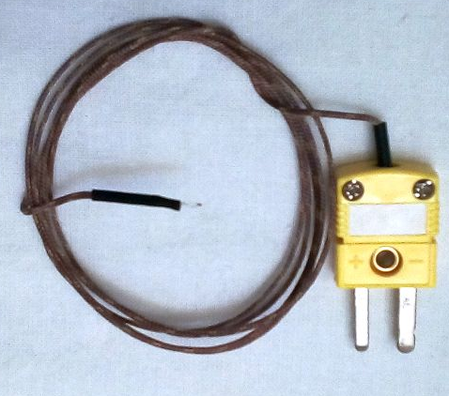
XK-TC 36/72" XK-TC 26/36 XK-TC 36/36

BOKAR International
650 Scranton Pocono Hwy.,
Covington Twp. PA 18444, USA
Tel: (570) 842-2812 Fax: (570) 842-4290
E-mail: bokar@bokar.com
www.bokar.com
SMT: www.Assembly-SMT.com www.SMT-tool.com www.X-Reflow306.com,
www.X-1003.com www.SMTrepair.com www.SMTFocus.com www.FineRework.com
www.SMTdispenser.com www.BestBatchOven.com www.SMT-ESD.com
ESD: www.ESDapparel.com www.ESDmeters.com www.ESDpackaging.net
www.ZeroCharge.net www.No-Stat.com www.ESDchair.com www.ESDlabcoats.com
www.ESDcarts.net www.ESDchair.com www.ESDbrushes.com
Other: www.SuperiorScrewdrivers.com www.Super-Iron.com
Latest Additions: www.ECOguardCC.com www.ULT.de

